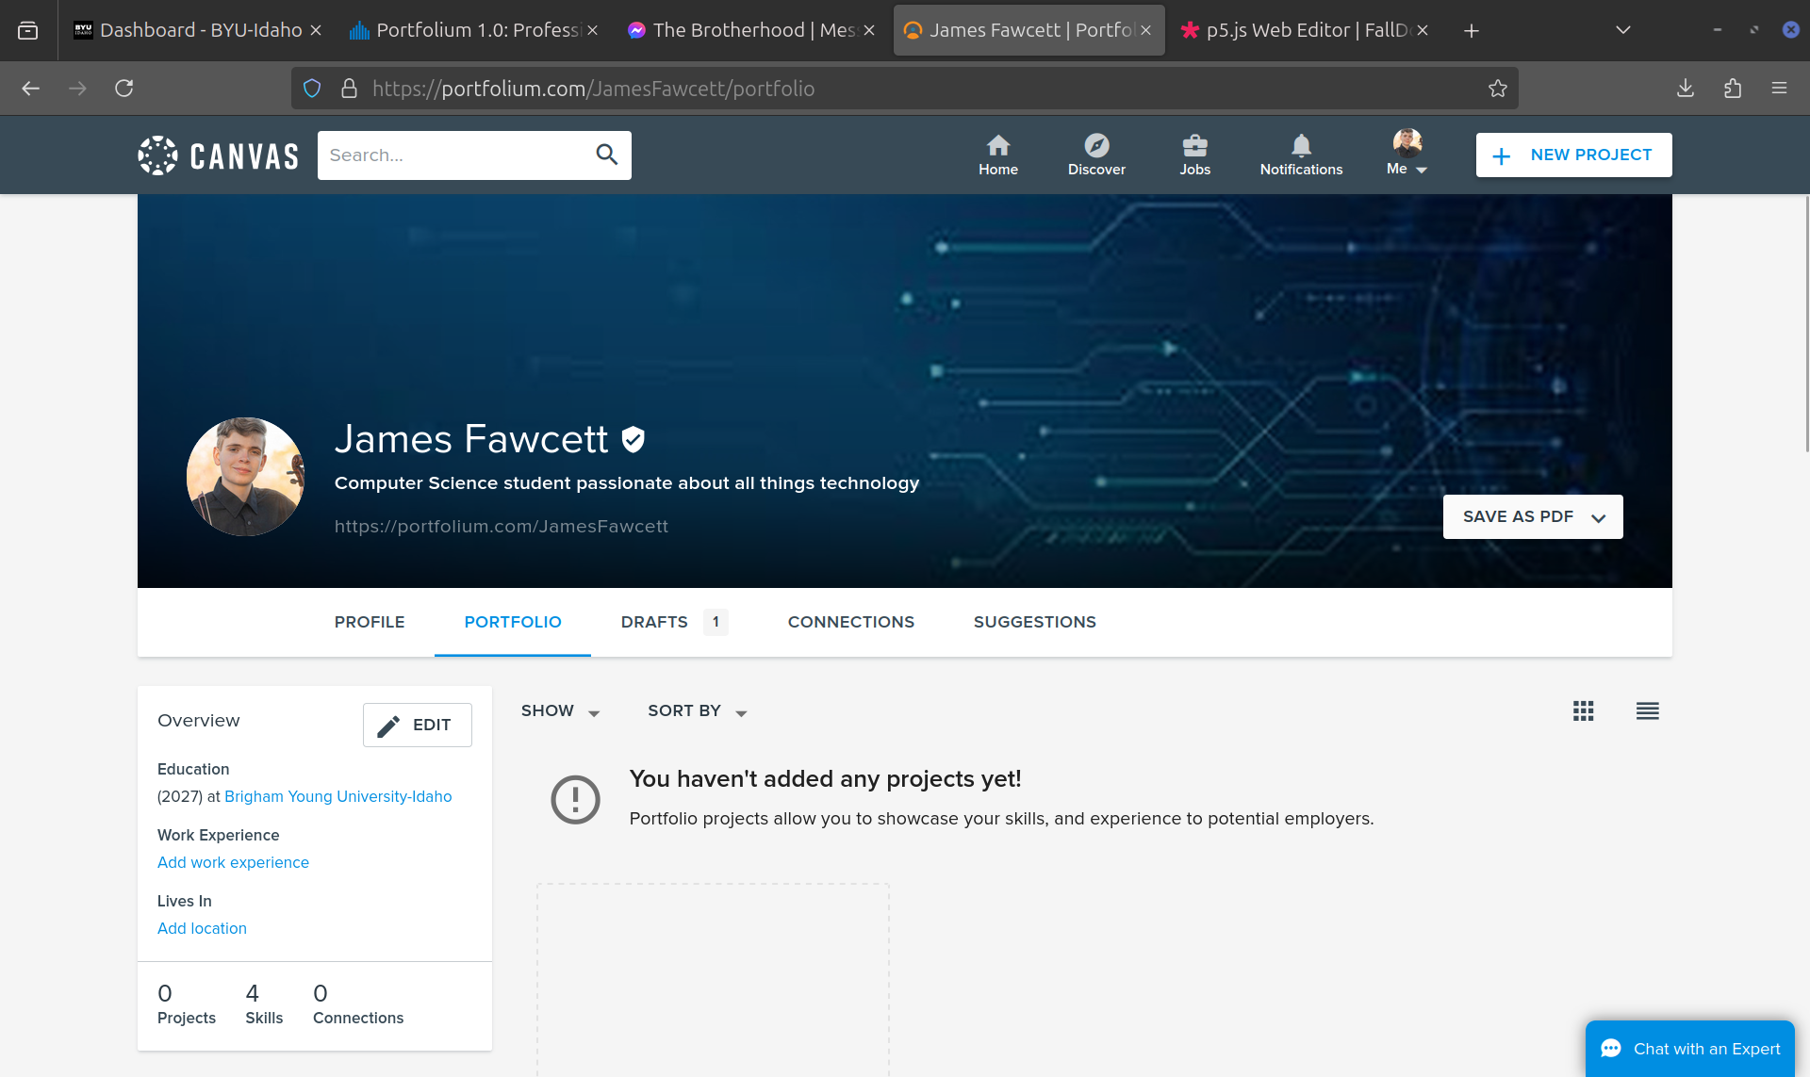
Portfolium seems to be a great way to showcase skills and projects I have worked on throughout my life. I will try to keep it as updated as possible, so potential employers can see it and have a quick understanding of my skills and experiences. I also plan on watching other profiles to see what other students are doing to get a better idea on what I should do. Keeping my portfolio updated will also help with me making me resume, by using its auto generate tool. This will help me apply for jobs quickly, by taking away the time it takes to create the resume.

